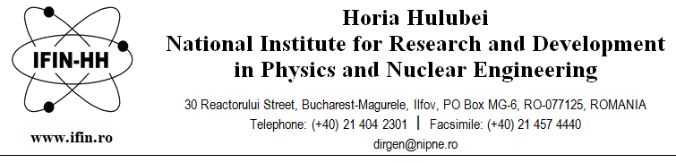
“Horia Hulubei” National Institute for Research and Development in Physics and Nuclear Engineering is hiring 1 scientific research assistant for a definite duration until 31st of December 2022, full time position, within the Department of Theoretical Physics.

Required skills:
- MSc/PhD student in physics, engineering, mathematics or related fields;
- good knowledge of quantum mechanics, quantum information;
- good programming skills;
- advanced English knowledge (reading/writing/speaking);
- good communications skills, team player and able to work independently.

Main responsibilities:
The project has three main objectives:
1. developing quantum gates and quantum protocols with optical vortices;
2. developing quantum communication protocols.

Application will contain the following documents:
- application form, available from www.nipne.ro/careers/jobs/jobs.php, specifying the name of the department;
- copies of degrees certificates;
- CV;
- proof of registration as MSc/PhD student or MSc diploma;
- copy of ID/passport.

Examination topics:
- quantum mechanics;
- quantum information theory, quantum technologies;
- protocols for quantum communication, quantum cryptography.

Bibliography:
M.Nielsen, I.Chuang- Quantum computation and quantum information, Cambridge Univ. Press (2010)
E.Rieffel, W.Polak- Quantum computing: a gentle introduction, MIT Press (2011)

The examination consists in a written test and an interview. The passing mark is 7 for both the written test and the interview (the interview will be held only by the candidates passing the written test). The final score is the average of the two marks.

Please send the application to resum@nipne.ro until 17.03.2022.
The written test and the interview will take place on 18.03.2022, at 10:00.
For more information, please call 021/404.61.78 or 021/404.23.00 ext. 5612, 5610.

